Big Mountain Resort Pricing Report

We know that Big Mountain Resort is a more luxurious and higher quality resort than most resorts in its market share. So why shouldn’t our ticket price reflect that? We set out to determine exactly how much of an increase in ticket price our high quality features would support. After cleaning and checking our data, we found that given that across Montana there is no price difference between weekday and weekend ticket prices our data supplied us with the most useable data if we focused on weekend prices as our comparison point across all resorts.

Firstly, we wanted to ensure that geographical location in the US wasn’t a major factor to ticket price. Do some resorts in more populous areas support higher ticket prices? What about resorts in states with higher or lower number of resorts per state? Which features most completely impact ticket price? We plotted the heatmap shown here: 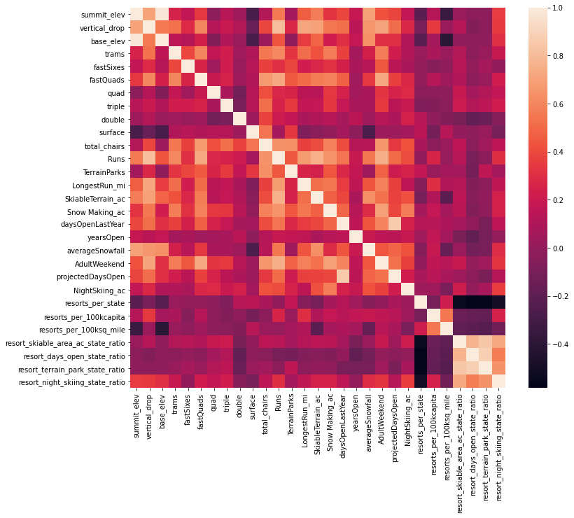

Which, at a high level examination, shows that none of the state specific metrics make a huge impact, and therefore we are safe to compare all resorts in our market share when looking for ticket price. After creating our model we dug further in to which of our exceptional features have the most impact on sustaining an increased ticket price. As shown in the bar chart below, the model we have the most confidence in suggests that our number of fast quads and our number of runs make the largest impact on ticket price, with total acres of snow making and total vertical drop coming in a distant third and fourth.

Currently, Big Mountain resort is charging 81 dollars. Our modeling suggests that this is under the sustainable ticket price. Our model suggests the resort should be able to maintain a ticket price of 95 dollars. Even if our model is at the maximum of its error, approximately 11 dollars, the resort can still support an increase. Moving forward we would recommend a handful of paths. The simplest strategy to implement is increasing ticket prices to 95 dollars, this action is the least intrusive to resort operations. Depending on resort goals, we have 2 other directions we would recommend going. If management is interested in investing more into the resort to further increase ticket price, we would recommend adding an additional run, increasing vertical drop distance by 150 feet, and adding an additional chair lift. With these actions we would expect to see a supported price increase of 1.99 per ticket, resulting in an estimated 3,474,638.00 dollars in increased revenue. Alternatively, if management is interested in closing down runs, shutting down one run makes no difference in expected ticket price, shutting down both 2 and 3 runs see a slight decrease in supported ticket price, though once we make a 3 run closure decrease closing 4 and 5 see no further decrease. We would not advise closing more than 5 runs at this time as we would see a sharper drop off in expected revenue.